**Section 1: Theory**

1. **Data Moat**

From my point of view, the term “moat” refers to business competitive advantage, as a result; data moat is business competitive advantages derived from utilizing data. The data moat can be treated under three topics:

* The data moat is created by combining proprietary (1st-party) data sources with others. A company is able to collect a huge amount of data; moreover, the process of combining data is unique (internal and external sources). Therefore the business insight generated is also various.
* Furthermore, we could consider how a company transform its data into business practices: building, improving and innovating customer services, using a more scientific, measurable and automated decision-making approaches in different fields such as marketing – targeting customers; efficient operations; generating actionable insights and people analytics in HR, these all benefits are fueled by AI and data

To sum up, “Competitors can copy your product but they can’t copy your data”.

1. **OLTP vs OLAP**

While OLTP database characterized by a large number of short on-line transactions, OLAP Database characterized by a relatively low volume of transactions. Furthermore, we could observe that OLTP database is more well-organized with fewer attributes and features; while OLAP database is enriched in terms of features engineering.

Additionally, because the queries are concluded into inserting, updating and deleting; the main concentration of building OLTP systems is to put on fast query processing, maintaining data integrity in multi-access among different environments and an effectiveness measured by a number of transactions per second. As a result of a wide database, OLAP queries are often very complex and involve aggregations.

Last but not least, OLTP Records are narrow and long which are suitable for real-time business operations; OLAP records are short and wide which mainly supports the purpose of data analysis, finding actionable business insights and decision-making.

1. **A modern data team - data professionals.**

A modern data team consists of data engineers, data scientists and data analysts.

Firstly, Data engineer is also called an ETL "Extract, transform, load" engineer who is responsible for moving and propagating access to data. They handle the beginning step of data processing: collecting; moving and storing data. As a result, it is a combination of computer science and database experience.

Secondly, data scientists rely more on mathematics/ statistics in order to develop predictive models or automated classifications. AI and Deep Learning are typical topics of data scientists.

The third one is a data analyst, who handles business questions by applying data. The three main languages are SQL, Python and R play a stellar role in business. Furthermore, a data analyst must be proficient in data visualization for not only discovering business insights but also explaining them to audiences – other departments.

1. **Data Privacy**

From my personal view, although data privacy law has been mentioned for a long time and governments attempt to develop it, regulation typically lags behind innovation. Tech giants such as Google, Facebook, Baidu… are “too big to fail”. They even have close connections with governments. As a result, users demand more competitiveness for them. Due to the reality that regulations could not catch up the innovations, however; a competitive market could protect and give more benefits to users. For many users, they have to accept the data privacy agreement given by these big companies, otherwise, they have no other options to satisfy the same customer’s needs.

1. **Car Owners and Cars**

Car and Car Owners relationship is M: N, we could see that a person is able to own more than one car, while a car is manufactured in mass production so that it could be sold to as many customers as within the company’s production capacity. In this case, we assume that a car is defined by its produced year; model and manufacturers. If we identify a car by series number or Vehicle registration plate; and period of time we could transform the many-to-many relationship (M: N) to 1:1. The middle entity should have a vehicle registration plate and time.

**Section 2: Database Design**

1. **Students M: M Classes**

As a result of many-to-many relationship, we should transform it into 1-to-1 relationship.

Learning from Hult, I added Team entity. Team will have Team Number as the Primary key in team table. Moreover, Student_ID and Class will consider as Foreign Keys to connect the two tables.

1. **Customers M: M Products**

Similar to the above relationship, we transform it into 1-to-1 relationship. However, I added 2 more tables: Order and Product_List. In Order table, it will show amount of units. When users dig into Order_ID, they could access to each unit of the specific order and the related price. SKU will be mentioned in Product_List as the Foreign Key, additionally; the SKU is then used as Primary Key in Product table.

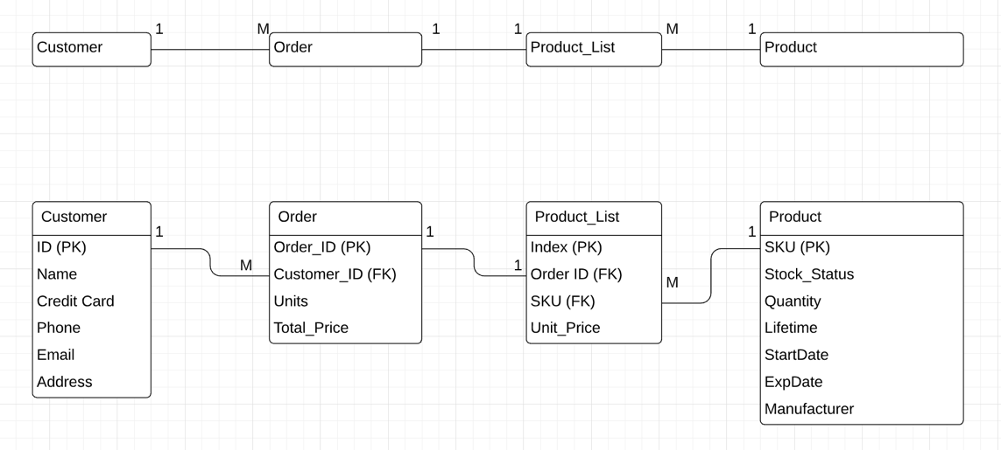

1. **ER diagram for a library reservation system for a family of libraries based on the given characteristics.**

We designed the database as followed:

Table of Borrowers with Borrower_ID as Primary Key, the table will contain information about the borrowers such as name, address, email and phone number. Similarly, I create tables of library, book and content. As all the relationships at this time are M: N, I create Request table to transform these relationships into 1: M. At this stage, we could achieve the fundamental requirements that multiple types of content that can be borrowed, borrow multiple items at the same time, borrow multiple types of content.

Furthermore, we could dig into local borrowers and book available in the local library. I created two more tables: Local_Borrowers to transform M: N between Borrowers and Library, as a result it is 1-to-1. Additionally, I create the Book_Available table to make Book and Library relationship M: N become 1-to-1.

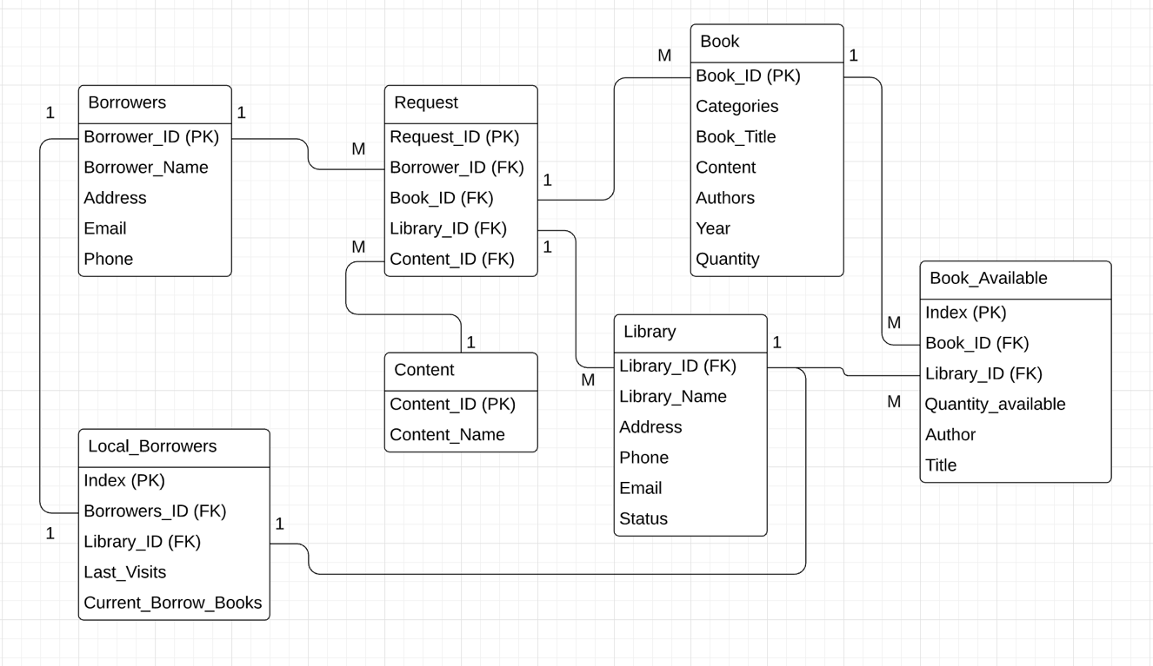

**Section 3: Data Analysis with SQL**

**Business Report**

The topic in this business report can best be treated under three headings: Understanding the problems, Finding the related business insights with SQL and recommendations.

Firstly, our users complained that customers frequently experience “empty” bike stations. I then using data analysis with SQL to find out empty stations and available ones. There are 758 available stations and 23 empty stations; as a result, we could expect that the proportion is merely **3%,** which is contrasting to our customers’ complaints.

There might be a risk that the available bikes are not working or in good condition. Instead of research empty (0) bikes, I look at the distribution of station has less than 5 bikes on the map of London. Unfortunately, there are many stations have **less than 5 bikes**. (Appendix 2 will provide a whole map)

Turning now to related business insights, we look at the busy stations, popular trips and usage peak (Appendix 4, 5 and 6). At first glance, the busiest stations are 191 Hyde Park, 307 Black Lion Gate, 303 Albert Gate, 785 Aquatic Centre, and 248 Triangle Car Park. It is an interesting business insight that the start stations and end stations are similar, we could assume that these are **tourism** trips; users ride around landmarks; moreover, they are also popular trips. Hence, we could expect that the majority of popular rides are for tourism. The third business insight relates to usage peak which is **8 AM** in **May** and **March**. May and March are considered as sweet months in London in which many events and outdoor activities (Reynolds, 2020).

Moving on now to consider recommendations, I strongly recommend reallocation of bikes and stations, according to SQL; I acknowledge that the company also has many free bikes which are located in various places; the map shows all the unused stations where the amount of **bikes equal to docks** (Appendix 3). If we could allocate them more appropriately; we could significantly reduce customer complaints. Additionally, our marketing plan should target on tourism users.

**References**

*Reynolds, L., 2020. 44 Brilliant Things To Do In London In May 2019. [online] Londonist. Available at: <https://londonist.com/london/things-to-do/things-to-do-in-london-in-may> [Accessed 29 March 2020].*

**Appendix**

* 1. ***Can you find any traces of empty stations?***

SELECT *

FROM `bigquery-public-data.london_bicycles.cycle_stations`

WHERE bikes_count = 0;

***If yes, how big is this problem?***

SELECT COUNT(*) AS AVAILABLE_STATION,

(SELECT COUNT(*)

FROM `bigquery-public-data.london_bicycles.cycle_stations`

WHERE bikes_count = 0)

AS EMPTY_STATION,

ROUND((SELECT COUNT(*)

FROM `bigquery-public-data.london_bicycles.cycle_stations`

WHERE bikes_count = 0) /

(SELECT COUNT(*)

FROM `bigquery-public-data.london_bicycles.cycle_stations`

WHERE bikes_count != 0),3) AS EMPTY_OVER_AVAILABLE

FROM `bigquery-public-data.london_bicycles.cycle_stations` WHERE bikes_count != 0;

* 1. ***We could consider using map to find out the distribution of station less than 5.***

SELECT

ST_GeogPoint(longitude, latitude) AS WKT,

bikes_count

FROM

`bigquery-public-data.london_bicycles.cycle_stations`

WHERE bikes_count < 5;

* 1. ***A further business insights from distribution of free stations, where bikes are full.***

SELECT

ST_GeogPoint(longitude, latitude) AS WKT,

bikes_count

FROM

`bigquery-public-data.london_bicycles.cycle_stations`

WHERE bikes_count = docks_count;

* 1. ***What are the most popular stations in the network?***

SELECT count(*) as frequency, end_station_id , start_station_id

FROM `bigquery-public-data.london_bicycles.cycle_hire`

WHERE end_station_id is not null and start_station_id is not null

GROUP BY end_station_id, start_station_id

ORDER BY frequency DESC;

* 1. ***When does their usage peak?***

SELECT

COUNT(*) as Frequency,

EXTRACT (DAYOFWEEK FROM start_date) as Day,

EXTRACT (HOUR FROM start_date) as Hour,

EXTRACT (MONTH FROM start_date) as Month

FROM `bigquery-public-data.london_bicycles.cycle_hire`

Group by Day, Hour, Month

ORDER BY Frequency DESC;

* 1. ***What are the most popular trips in the network?***

SELECT concat(end_station_id,' ',start_station_id) as Trip,

count(concat(end_station_id,' ',start_station_id)) as Number_of_Trip,

start_station_name,

end_station_name

FROM `bigquery-public-data.london_bicycles.cycle_hire`

WHERE end_station_id is not null and start_station_id is not null

Group by Trip, start_station_name, end_station_name

Order by Number_of_Trip DESC;

